Assignment-02_web form
1. Create an ASP.Net page to enter the details for student with the help of different views using MultiView Control. View 1: Student Personal
Info(Name,Gender,Address,Degree,etc..) View 2: Student Contact
Info(Email,Contact No,etc..) View 3: Show summery(View1+View2).

Code:
Student.aspx code:
<%@ Page Language="C#" AutoEventWireup="true"
CodeBehind="StudentRegistration.aspx.cs" Inherits="WebApplication1.StudentRegistration" %>

<!DOCTYPE html>

<html xmlns="http://www.w3.org/1999/xhtml">
<head runat="server">
<title>Student Registration - MultiView Control</title>
<style type="text/css"> body { font-family: 'Segoe UI', Tahoma, Geneva, Verdana, sans-serif; background-color: #f4f6f9; margin: 40px;
}
.container { width: 550px; margin: 0 auto; background: #ffffff; padding: 30px 40px; border-radius: 8px; box-shadow: 0 4px 15px rgba(0,0,0,0.1);
} h2 { color: #2c3e50; text-align: center; margin-bottom: 20px;
}
.step-indicator { text-align: center; font-weight: bold; color: #007bff; margin-bottom: 20px; font-size: 16px;
padding: 8px; background-color: #e9f5ff; border-radius: 4px;
}
.form-group { margin-bottom: 15px;
}
.form-group label { display: block; margin-bottom: 5px; font-weight: bold; color: #555;
}
.form-control { width: 100%; padding: 8px 10px; box-sizing: border-box; border: 1px solid #ccc; border-radius: 4px; font-size: 14px;
}
.btn {
padding: 9px 20px; background-color: #007bff; color: white; border: none; border-radius: 4px; cursor: pointer; font-size: 14px; font-weight: bold;
}
.btn-secondary { background-color: #6c757d;
}
.btn:hover { opacity: 0.9;
}
.btn-group { margin-top: 25px; display: flex; justify-content: space-between;
}
.summary-table { width: 100%; border-collapse: collapse; margin-top: 15px;
}
.summary-table td { padding: 10px; border-bottom: 1px solid #eee;
}
.summary-table td.label-col { font-weight: bold; width: 35%; color: #333;
}
</style>
</head>
<body>
<form id="form1" runat="server">
<div class="container">
<h2>Student Details Form</h2>

<asp:MultiView ID="MultiView1" runat="server" ActiveViewIndex="0">
<%-- View 1: Student Personal Info --%>
<asp:View ID="View1" runat="server">
<div class="step-indicator">View 1: Student Personal Info</div> <div class="form-group">
<asp:Label ID="lbl1" runat="server" Text="Student Name:"></asp:Label>
<asp:TextBox ID="txtName" runat="server" CssClass="form-control"></asp:TextBox>
<asp:RequiredFieldValidator ID="rfvName" runat="server"
ControlToValidate="txtName" ErrorMessage="Name is required" ForeColor="Red"
ValidationGroup="Group1"></asp:RequiredFieldValidator>
</div>

<div class="form-group">
<asp:Label ID="lbl2" runat="server" Text="Gender:"></asp:Label>
<asp:RadioButtonList ID="rblGender" runat="server"
RepeatDirection="Horizontal">
<asp:ListItem Selected="True">Male</asp:ListItem>
<asp:ListItem>Female</asp:ListItem>
<asp:ListItem>Other</asp:ListItem>
</asp:RadioButtonList>
</div>

<div class="form-group">
<asp:Label ID="lbl3" runat="server" Text="Address:"></asp:Label>
<asp:TextBox ID="txtAddress" runat="server" TextMode="MultiLine" Rows="3"
CssClass="form-control"></asp:TextBox>
<asp:RequiredFieldValidator ID="rfvAddress" runat="server"
ControlToValidate="txtAddress" ErrorMessage="Address is required" ForeColor="Red"
ValidationGroup="Group1"></asp:RequiredFieldValidator>
</div>

<div class="form-group">
<asp:Label ID="lbl4" runat="server" Text="Degree / Course:"></asp:Label>
<asp:DropDownList ID="ddlDegree" runat="server" CssClass="form-control">
<asp:ListItem>B.Tech</asp:ListItem>
<asp:ListItem>B.Sc</asp:ListItem>
<asp:ListItem>BCA</asp:ListItem>
<asp:ListItem>M.Tech</asp:ListItem>
<asp:ListItem>MCA</asp:ListItem>
<asp:ListItem>M.Sc</asp:ListItem>
</asp:DropDownList>
</div>

<div class="btn-group">
<div></div>
<asp:Button ID="btnNext1" runat="server" Text="Next (Contact Info) >>" CssClass="btn" ValidationGroup="Group1" OnClick="btnNext1_Click" />
</div>
</asp:View>

<%-- View 2: Student Contact Info --%>
<asp:View ID="View2" runat="server">
<div class="step-indicator">View 2: Student Contact Info</div>

<div class="form-group">
<asp:Label ID="lbl5" runat="server" Text="Email Address:"></asp:Label>
<asp:TextBox ID="txtEmail" runat="server" CssClass="form-control"></asp:TextBox>
<asp:RequiredFieldValidator ID="rfvEmail" runat="server"
ControlToValidate="txtEmail" ErrorMessage="Email is required" ForeColor="Red"
ValidationGroup="Group2"></asp:RequiredFieldValidator>
<asp:RegularExpressionValidator ID="revEmail" runat="server"
ControlToValidate="txtEmail" ErrorMessage="Invalid Email Format" ForeColor="Red"
ValidationExpression="\w+([-+.']\w+)*@\w+([-.]\w+)*\.\w+([-.]\w+)*" ValidationGroup="Group2"></asp:RegularExpressionValidator>
</div>

<div class="form-group">
<asp:Label ID="lbl6" runat="server" Text="Contact No:"></asp:Label>
<asp:TextBox ID="txtContact" runat="server" CssClass="form-control"></asp:TextBox>
<asp:RequiredFieldValidator ID="rfvContact" runat="server"
ControlToValidate="txtContact" ErrorMessage="Contact number is required" ForeColor="Red"
ValidationGroup="Group2"></asp:RequiredFieldValidator>
<asp:RegularExpressionValidator ID="revContact" runat="server"
ControlToValidate="txtContact" ErrorMessage="Must be 10 digits" ForeColor="Red"
ValidationExpression="\d{10}" ValidationGroup="Group2"></asp:RegularExpressionValidator>
</div>

<div class="form-group">
<asp:Label ID="lbl7" runat="server" Text="City:"></asp:Label>
<asp:TextBox ID="txtCity" runat="server" CssClass="form-control"></asp:TextBox>
<asp:RequiredFieldValidator ID="rfvCity" runat="server"
ControlToValidate="txtCity" ErrorMessage="City is required" ForeColor="Red"
ValidationGroup="Group2"></asp:RequiredFieldValidator>
</div>

<div class="btn-group">
<asp:Button ID="btnPrev2" runat="server" Text="<< Previous (Personal Info)" CssClass="btn btn-secondary" OnClick="btnPrev2_Click" CausesValidation="false" />
<asp:Button ID="btnNext2" runat="server" Text="Next (Show Summary) >>" CssClass="btn" ValidationGroup="Group2" OnClick="btnNext2_Click" />
</div>
</asp:View>

<%-- View 3: Show Summary (View 1 + View 2) --%>
<asp:View ID="View3" runat="server">
<div class="step-indicator">View 3: Student Summary</div>

<table class="summary-table">
<tr>
<td class="label-col">Name:</td>
<td><asp:Label ID="lblSummaryName" runat="server"></asp:Label></td>
</tr>
<tr>
<td class="label-col">Gender:</td>
<td><asp:Label ID="lblSummaryGender" runat="server"></asp:Label></td>
</tr>
<tr>
<td class="label-col">Address:</td>
<td><asp:Label ID="lblSummaryAddress" runat="server"></asp:Label></td>
</tr>
<tr>
<td class="label-col">Degree:</td>
<td><asp:Label ID="lblSummaryDegree" runat="server"></asp:Label></td>
</tr>
<tr>
<td class="label-col">Email:</td>
<td><asp:Label ID="lblSummaryEmail" runat="server"></asp:Label></td>
</tr>
<tr>
<td class="label-col">Contact No:</td>
<td><asp:Label ID="lblSummaryContact" runat="server"></asp:Label></td>
</tr>
<tr>
<td class="label-col">City:</td>
<td><asp:Label ID="lblSummaryCity" runat="server"></asp:Label></td>
</tr>
</table>

<asp:Label ID="lblStatusMessage" runat="server" ForeColor="Green"
Font-Bold="true" style="display:block; margin-top:15px; text-align:center;"></asp:Label>

<div class="btn-group">
<asp:Button ID="btnPrev3" runat="server" Text="<< Edit Contact Info"
CssClass="btn btn-secondary" OnClick="btnPrev3_Click" CausesValidation="false" />
<asp:Button ID="btnSubmit" runat="server" Text="Final Submit" CssClass="btn" OnClick="btnSubmit_Click" CausesValidation="false" />
</div>
</asp:View>
</asp:MultiView>
</div>
</form>
</body>
</html>

Student.apsx.cs code:
using System; using System.Web.UI; using System.Web.UI.WebControls;

namespace WebApplication1
{
public partial class StudentRegistration : System.Web.UI.Page
{
protected void Page_Load(object sender, EventArgs e)
{ if (!IsPostBack)
{
MultiView1.ActiveViewIndex = 0;
}
}

protected void btnNext1_Click(object sender, EventArgs e)
{
// Move to View 2: Contact Info
MultiView1.ActiveViewIndex = 1;
}

protected void btnPrev2_Click(object sender, EventArgs e)
{
// Move back to View 1: Personal Info
MultiView1.ActiveViewIndex = 0;
}

protected void btnNext2_Click(object sender, EventArgs e)
{
// Populate View 3 Summary labels from View 1 and View 2 inputs lblSummaryName.Text = txtName.Text; lblSummaryGender.Text = rblGender.SelectedValue; lblSummaryAddress.Text = txtAddress.Text; lblSummaryDegree.Text = ddlDegree.SelectedValue; lblSummaryEmail.Text = txtEmail.Text; lblSummaryContact.Text = txtContact.Text; lblSummaryCity.Text = txtCity.Text;

// Move to View 3: Summary
MultiView1.ActiveViewIndex = 2;
}

protected void btnPrev3_Click(object sender, EventArgs e)
{
// Move back to View 2: Contact Info
MultiView1.ActiveViewIndex = 1;
}

protected void btnSubmit_Click(object sender, EventArgs e)
{
lblStatusMessage.Text = "Student Details Submitted Successfully!"; btnSubmit.Enabled = false;
}
}
}

Output:
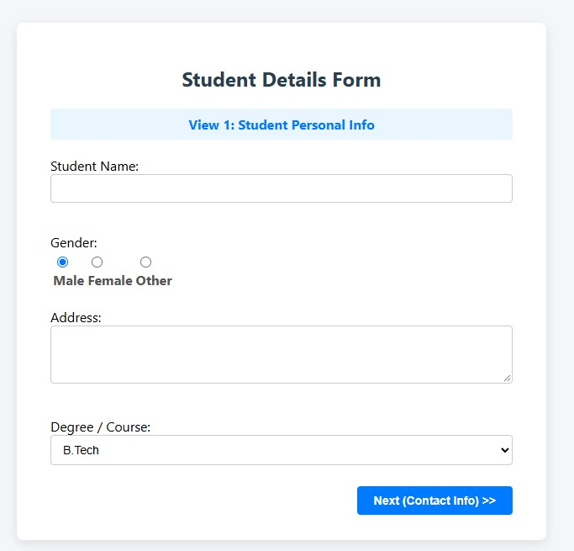
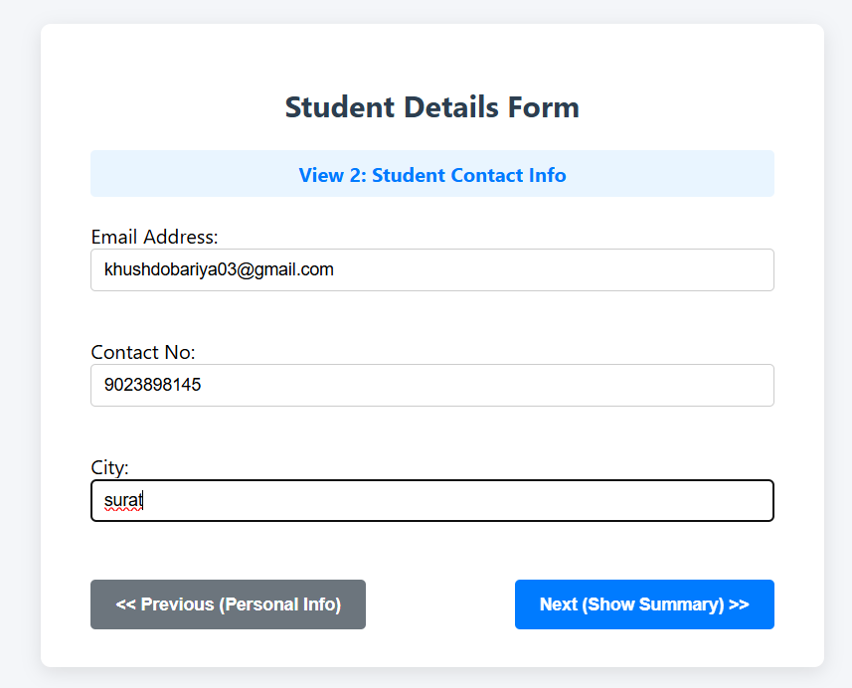
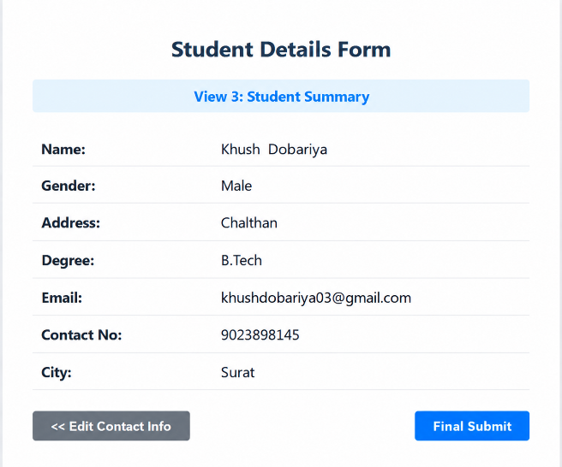
2. Design a registration form using different validation controls.
Code:
webApplication.apsx code:
<%@ Page Language="C#" AutoEventWireup="true" CodeBehind="WebForm2.aspx.cs" Inherits="WebApplication1.WebForm2" %>

<!DOCTYPE html>

<html xmlns="http://www.w3.org/1999/xhtml">
<head runat="server">
<title>Validation Control Demo</title> <script type="text/javascript"> function validateAge(source, args) { var number = parseInt(args.Value, 10); if (!isNaN(number) && number % 2 === 0) { args.IsValid = true;
} else { args.IsValid = false;
}
}
</script>

</head>
<body style="margin-left: 640px">
<form id="form1" runat="server">
Validation control demo<br />
<br />
<asp:Label ID="Label1" runat="server" Text="Name"></asp:Label>
:
<asp:TextBox ID="name" runat="server"></asp:TextBox>

<asp:RequiredFieldValidator runat="server" ControlToValidate="name"
ErrorMessage="Name is Required" ForeColor="#FF3300"></asp:RequiredFieldValidator>
<br />
<br />
<asp:Label ID="Label2" runat="server" Text="Password"></asp:Label>
:
<asp:TextBox ID="pass" runat="server" TextMode="Password"></asp:TextBox> <asp:RequiredFieldValidator ID="RequiredFieldValidator2" runat="server"
ControlToValidate="pass" ErrorMessage="Password is Required"

ForeColor="Red"></asp:RequiredFieldValidator>
<br />
<br />
<asp:Label ID="Label3" runat="server" Text="Confirm Password"></asp:Label>
:
<asp:TextBox ID="cpass" runat="server" TextMode="Password"></asp:TextBox>
<asp:RequiredFieldValidator ID="RequiredFieldValidator3" runat="server"
ControlToValidate="cpass" ErrorMessage="Password is Required"

ForeColor="#CC0000"></asp:RequiredFieldValidator>
<br />
<asp:CompareValidator ID="CompareValidator1" runat="server"
ControlToCompare="pass" ControlToValidate="cpass" ErrorMessage="Passwords don't match" ForeColor="Red"></asp:CompareValidator>
<br />
<br />
<asp:Label ID="Label4" runat="server" Text="Email"></asp:Label>
:
<asp:TextBox ID="email" runat="server"></asp:TextBox>
<asp:RequiredFieldValidator ID="RequiredFieldValidator4" runat="server"
ControlToValidate="email" ErrorMessage="Email Is Required"

ForeColor="Red"></asp:RequiredFieldValidator>
<br />
<asp:RegularExpressionValidator ID="RegularExpressionValidator1" runat="server"
ControlToValidate="email" ErrorMessage="Invalid Email" ForeColor="Red" ValidationExpression="\w+([-+.']\w+)*@\w+([-.]\w+)*\.\w+([-.]\w+)*"></asp:RegularExpressionVal idator>
<br />
<br />
<asp:Label ID="Label5" runat="server" Text="Age"></asp:Label>
:
<asp:TextBox ID="age" runat="server"></asp:TextBox>
<asp:RequiredFieldValidator ID="RequiredFieldValidator5" runat="server"
ControlToValidate="age" ErrorMessage="Age Is Required"

ForeColor="Red"></asp:RequiredFieldValidator>
<br />
<asp:RangeValidator ID="RangeValidator1" runat="server" ControlToValidate="age"
ErrorMessage="Age must be between 1 and 100" ForeColor="Red" MaximumValue="100" MinimumValue="1" Type="Integer"></asp:RangeValidator>
<br />
<asp:CustomValidator ID="CustomValidator1" runat="server" ControlToValidate="age"
ErrorMessage="Age must be an even number" ForeColor="Red"
ClientValidationFunction="validateAge"
OnServerValidate="CustomValidator1_ServerValidate"></asp:CustomValidator>
<br />
<br />
<asp:Label ID="Label6" runat="server" Text="Phone"></asp:Label>
:
<asp:TextBox ID="phone" runat="server"></asp:TextBox>
<asp:RequiredFieldValidator ID="RequiredFieldValidator6" runat="server"
ControlToValidate="phone" ErrorMessage="Phone number Is Required"

ForeColor="Red"></asp:RequiredFieldValidator>
<br />
<asp:RegularExpressionValidator ID="RegularExpressionValidator2" runat="server"
ControlToValidate="phone" ErrorMessage="Invalid Number" ForeColor="Red"

ValidationExpression="\d{10}"></asp:RegularExpressionValidator>
<br />
<br />
<br />
<asp:Button ID="Button1" runat="server" Text="Submit" />
<br />
<br />
</form>
</body>

</html>

webApplication.apsx.cs code:
using System; using System.Collections.Generic; using System.Linq; using System.Web; using System.Web.UI; using System.Web.UI.WebControls; namespace WebApplication1
{
public partial class WebForm2 : System.Web.UI.Page
{
protected void Page_Load(object sender, EventArgs e)
{

}

protected void CustomValidator1_ServerValidate(object source, ServerValidateEventArgs args)
{ int ageVal; if (int.TryParse(args.Value, out ageVal) && ageVal % 2 == 0)
{ args.IsValid = true;
} else
{ args.IsValid = false;
}
}
}
}
Output:
